

THE UNIVERSITY OF AZAD JAMMU AND KASHMIR, MUZAFFARABAD
Department of Software Engineering

STUDENT NAME: | SHAHZAD AHMED AWAN
STUDENT ROLL NO: | 2024-SE-15
LAB: | Open ended Lab
COURSE TITLE: | Data Structure & Algorithm
COURSE CODE: | CS-2101
INSTRUCTOR: | Engr. Asma Javed
SUBMISSION DATE: | 16th January, 2026

Table of Contents
OPEN ENDED LAB (OEL) 3
Lab Title 3
Lab Type 3
Objective 3
Tools & Technologies 3
Theoretical Background 3
Types of Graphs 3
Graph Representations 4
Graph Traversal Algorithms 4
Implementation Details 4
Program 1: Graph Representation using Adjacency Matrix: 4
Program 2: Graph Representation using Adjacency List 6
Program 3: Breadth First Search (BFS) Traversal 8
Program 4: Depth First Search (DFS) Traversal 10
Results & Observations 12
Conclusion 12
Reflection 12

Table of Figure:
Figure 1: Graph representation using adjacency matrix Code -1 4
Figure 2: Graph representation using adjacency matrix Code -2 5
Figure 3: Graph representation using adjacency matrix Output 5
Figure 4: Graph Representation using Adjacency List Code -1 6
Figure 5: Graph Representation using Adjacency List Code- 2 7
Figure 6: Graph Representation using Adjacency List Output 7
Figure 7: Breadth First Search (BFS) Traversal Code -01 8
Figure 8: Figure 8: Breadth First Search (BFS) Traversal using queue Output 9
Figure 9: Figure 8: Breadth First Search (BFS) Traversal using queue Code -02 9
Figure 10: DFS Traversal using Recursion Code -01 10
Figure 12: DFS Traversal using Recursion Output 11
Figure 11: DFS Traversal using Recursion Code -02 11

OPEN ENDED LAB (OEL)

Lab Title
Graph Data Structure Implementation in C++

Lab Type
Open Ended Lab (Self-Learning & Implementation)

Objective
The objective of this Open-Ended Lab (OEL) is to independently study and implement the Graph data structure in C++. This lab aims to strengthen understanding of graph concepts, graph representations, and traversal algorithms such as Breadth First Search (BFS) and Depth First Search (DFS) through practical implementation.

Tools & Technologies
- Programming Language: C++
- Compiler/IDE: Dev C++

Theoretical Background
A graph is a non-linear data structure consisting of vertices (nodes) and edges (connections). Graphs are widely used to model real-world problems such as computer networks, road maps, and social networks.

Types of Graphs
- Directed Graph: Edges have direction
- Undirected Graph: Edges have no direction
- Weighted Graph: Edges contain weights or costs

Graph Representations
- Adjacency Matrix:
A 2D array representation where 1 shows an edge and 0 shows no edge.
- Adjacency List:
Each vertex maintains a list of its adjacent (connected) vertices.

Graph Traversal Algorithms
- Breadth First Search (BFS): Traverses the graph level by level using a queue.
- Depth First Search (DFS): Traverses the graph deeply using recursion or stack.

Implementation Details

Program 1: Graph Representation using Adjacency Matrix:
This program represents a graph using a 2D adjacency matrix. The user provides the number of vertices, edges, and their connections.
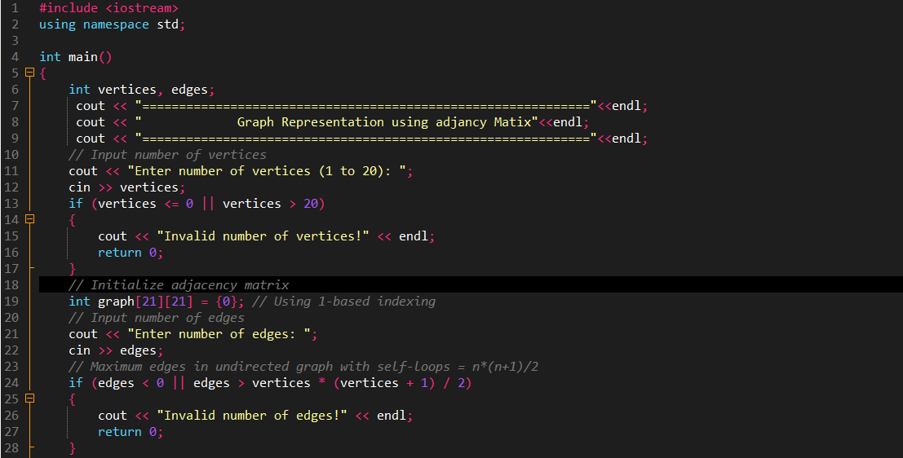
Code:
Figure 1: Graph representation using adjacency matrix Code -1
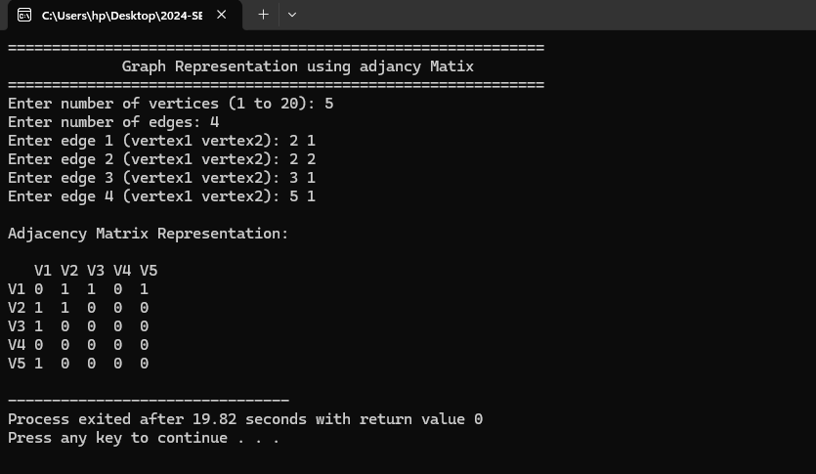
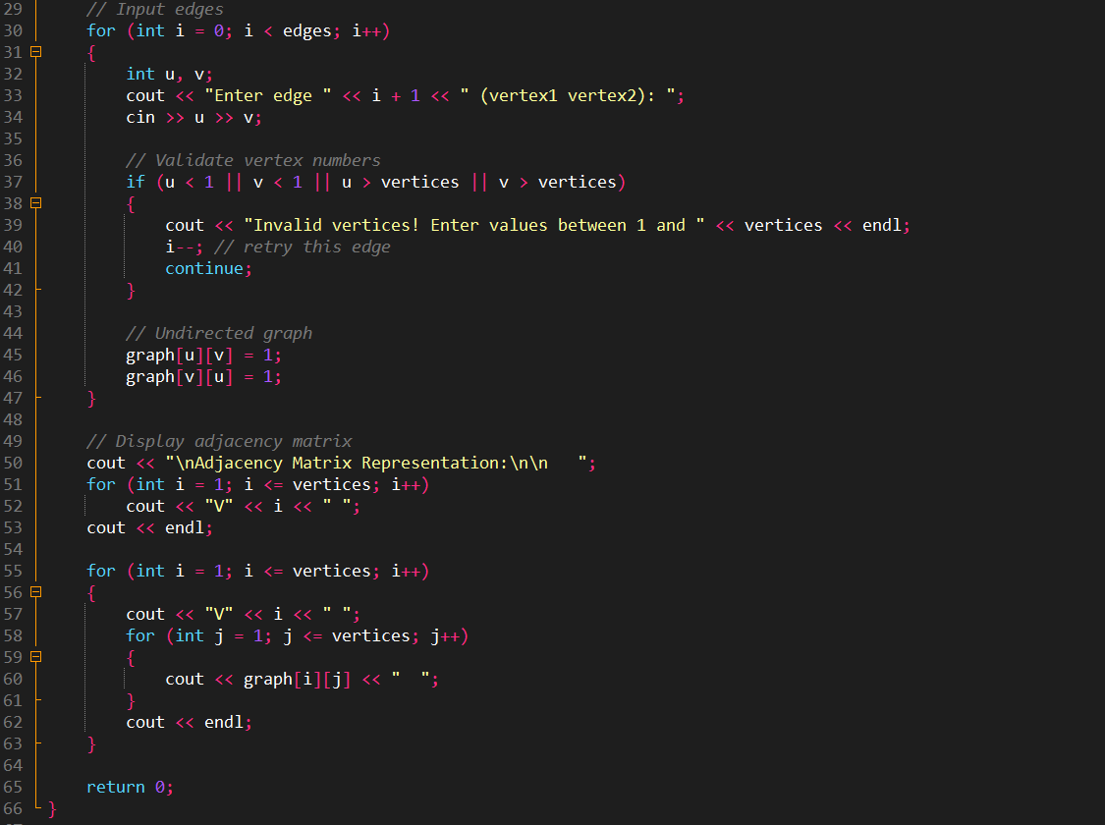
Output:
Figure 2: Graph representation using adjacency matrix Code -2
Figure 3: Graph representation using adjacency matrix Output

Program 2: Graph Representation using Adjacency List
This program represents a graph using an adjacency list, where each vertex stores a list of connected vertices.
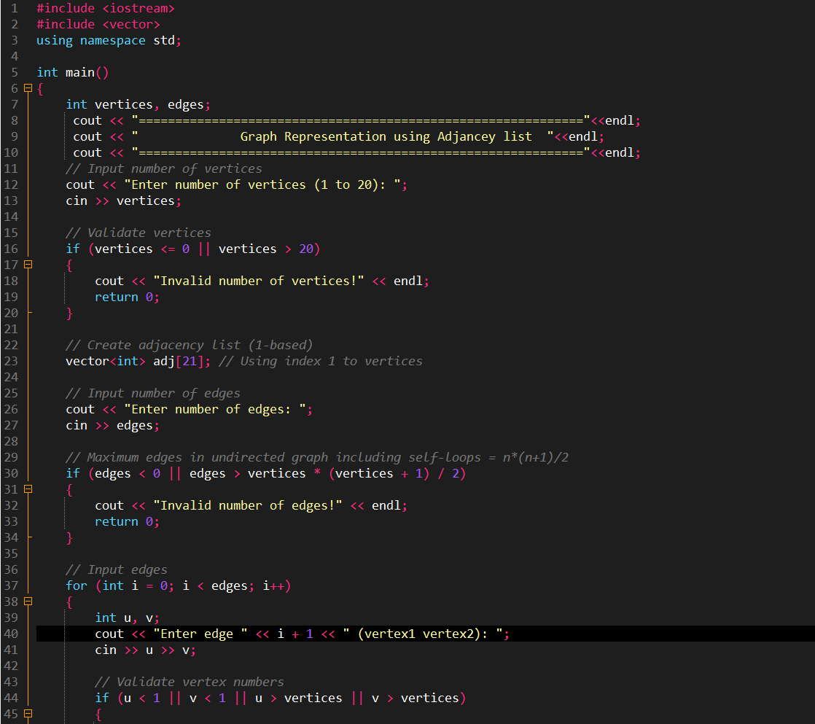
Code:
Figure 4: Graph Representation using Adjacency List Code -1

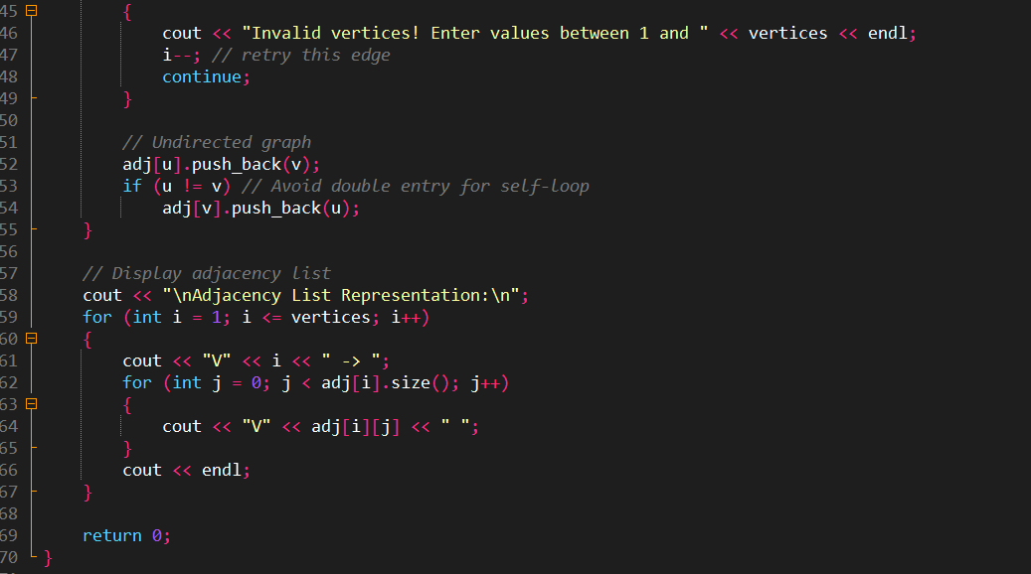
Output Placeholder:
Figure 5: Graph Representation using Adjacency List Code- 2
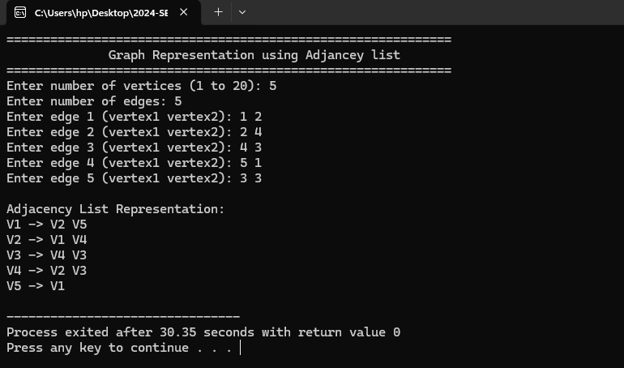
Figure 6: Graph Representation using Adjacency List Output

Program 3: Breadth First Search (BFS) Traversal
This program performs BFS traversal starting from a user-defined vertex using a queue.
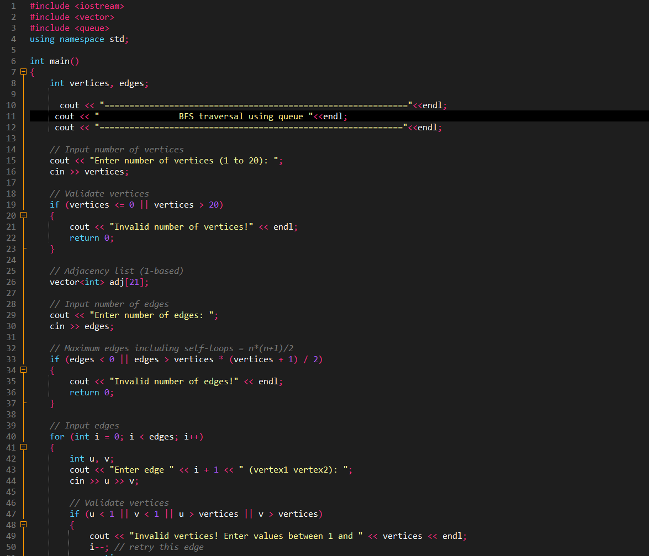
Code:
Figure 7: Breadth First Search (BFS) Traversal Code -01

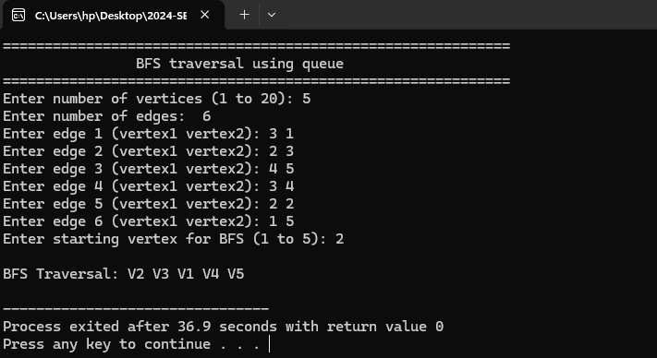
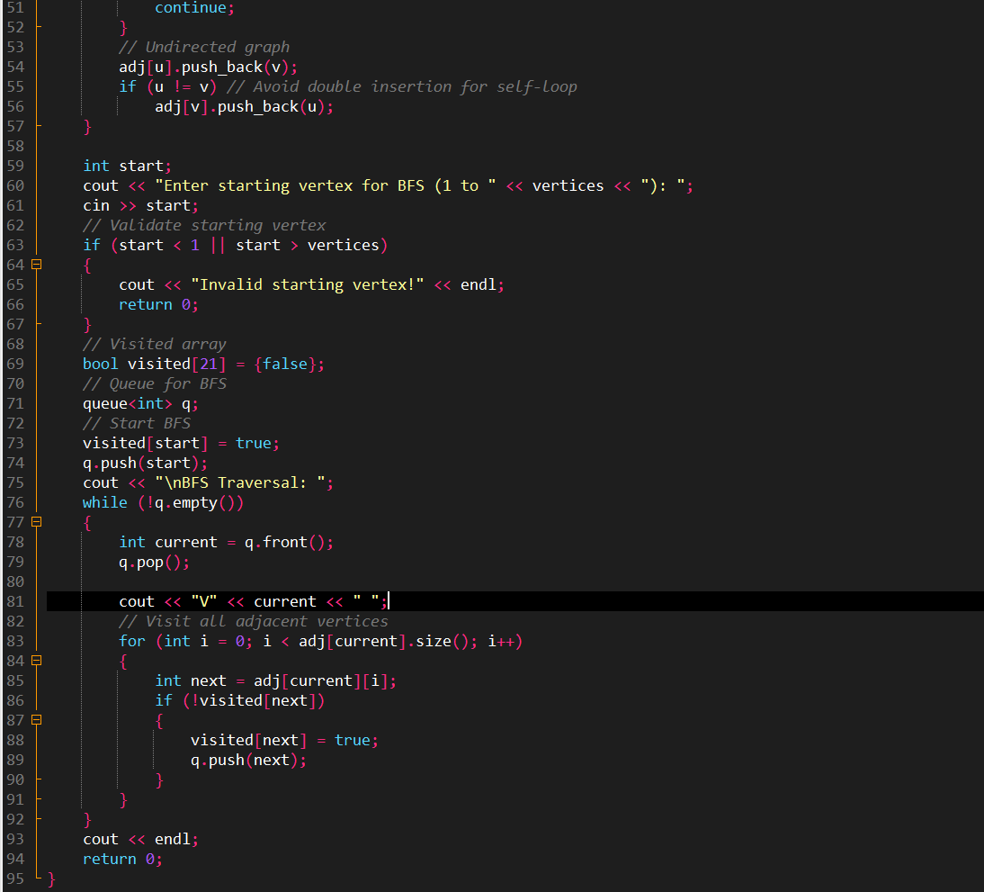
Output:
Figure 8: Figure 8: Breadth First Search (BFS) Traversal using queue Output
Figure 9: Figure 8: Breadth First Search (BFS) Traversal using queue Code -02

Program 4: Depth First Search (DFS) Traversal
This program performs DFS traversal using recursion, visiting a vertex completely before moving to the next.
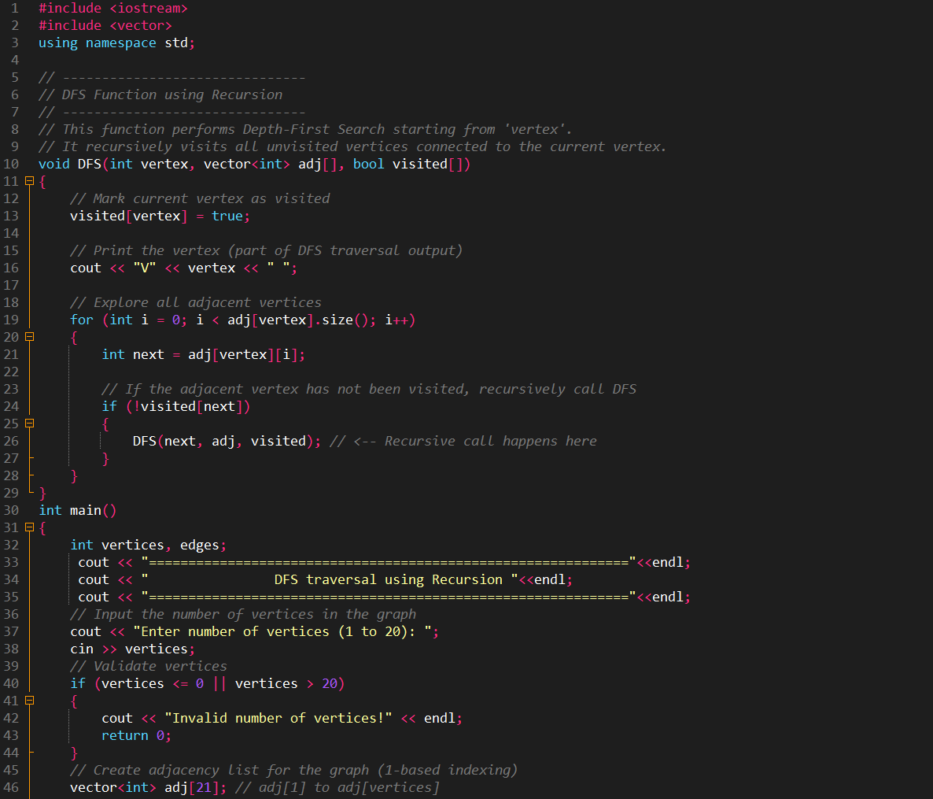
Code:
Figure 10: DFS Traversal using Recursion Code -01
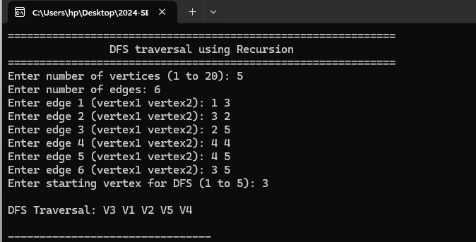
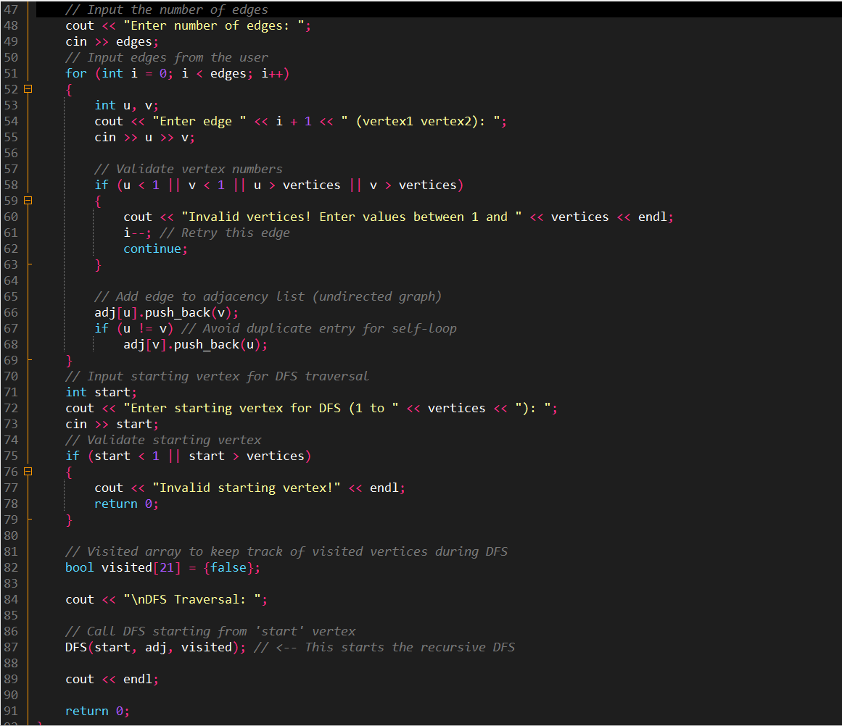
Output:
Figure 11: DFS Traversal using Recursion Output
Figure 12: DFS Traversal using Recursion Code -02

Results & Observations
- Graphs can be represented efficiently using both adjacency matrix and adjacency list.
- BFS explores vertices in breadth-wise order using a queue.
- DFS explores vertices deeply using recursion.
- User-controlled input makes the programs flexible and reusable.

Conclusion
This Open-Ended Lab provided practical exposure to graph data structures and their traversal techniques. Through self-learning and implementation, a clear understanding of BFS and DFS algorithms was achieved. The lab improved problem-solving skills and reinforced concepts of non-linear data structures in C++.

Reflection
After completing this OEL, I am able to:
- Understand graph concepts and terminology
- Implement graph representations in C++
- Apply BFS and DFS traversal algorithms
- Develop clean and beginner-level graph programs

